|  |  |
| --- | --- |
|  | **Crime Management System**  **Technical Design Document** |
| |  |  |  |  | | --- | --- | --- | --- | |  | **Prepared By / Last Updated By** | **Reviewed By** | **Approved By** | | **Name** | Arpita Bhargava  Vivek Sheel Shakya  Avanija S.  Suvidya Sharma  Vignesh K. |  |  | | **Role** | POD Leader POD Member POD Member POD Member POD Member |  |  | | **Signature** |  |  |  | | **Date** | 17th May, 2021 |  |  | |
|  |

Table of Contents

1.0 Introduction 3

1.1 Purpose of this document 3

1.2 Project overview 3

2.0 Solution Summary 3

2.1 Scope 3

2.2 Assumptions 3

2.3 Dependencies 3

2.4 Risks 3

3.0 Schematic Diagram 3

4.0 System Design 4

4.1 Proposed design 4

4.2 Component inventory 4

5.0 Database Design 4

5.1 Data Model 4

5.2 Tables Structure 4

6.0 Appendices 4

6.1 Glossary 4

6.2 Other 5

7.0 Terms & Conditions 5

8.0 Change Log 5

# Introduction

## Purpose of this document

The purpose of this document is to document the technical design, component details and Database design. This will also capture the scope, assumptions, risk, dependencies of this project.

## Project overview

*Managing crime is a challenging task. The more complex and populated a society is, more are the crimes that needs to be controlled by the ruling body through armed forces. The current system for handling these crimes is facing a lot of difficulties. There is no instant means for reporting crimes. People have to go to the police station to file complaints. The process is time consuming and lacks transparency. The proposed system will help eliminate the limitations of the existing system. Digitalizing the current system will make it easier to file and track complaints and will also reduce the manual work of managing the records. The proposed system is a web application for online complaining and management of crime records. This system has three users – public users, police stations and admin. Admin will manage users and police stations. Public users can also file a complaint by registering themselves on the system. After the admin authenticates the visitor, he or she can file a complaint. The complaint would be directed to the nearest police station and a complaint id would be generated using which status of the complaints can be tracked. This application can be used by police for managing the data. Some of the modules like unidentified dead bodies, missing persons, most wanted criminals and news and blogs can be viewed without logging in.*

# Solution Summary

## Scope

*Registered User:*

* *Should be able to login to the portal using username and password.*
* *Should be able to file and track status of the complaints.*
* *Should be able to access the contents of the website.*

*Visitor:*

* *Should be able to register and login to the portal using username and password.*
* *Should be able to access the contents of the website.*

*Police:*

* *Should be able to view the complaints filed.*
* *Should be able to update the status of the complaints.*

*Admin:*

* *Should be able to see the complaints and remove the complaints that are not valid.*
* *Should be able to view details of the registered user and remove them from system.*
* *Should be able to add/delete/remove police station.*
* *Should be able to remove resolved complaints.*

## Assumptions

*<This sub-section shall state the assumptions of this detailed design document>*

## Dependencies

Eclipse IDE Version 4.12

## Risks

*<This sub-section shall state the risks predicted for this project>*

# Schematic Diagram

A schematic, or schematic diagram, is a representation of the elements of a [system](https://en.wikipedia.org/wiki/System) using abstract, graphic [symbols](https://en.wikipedia.org/wiki/Symbol) rather than realistic pictures. It gives an overview of overall system

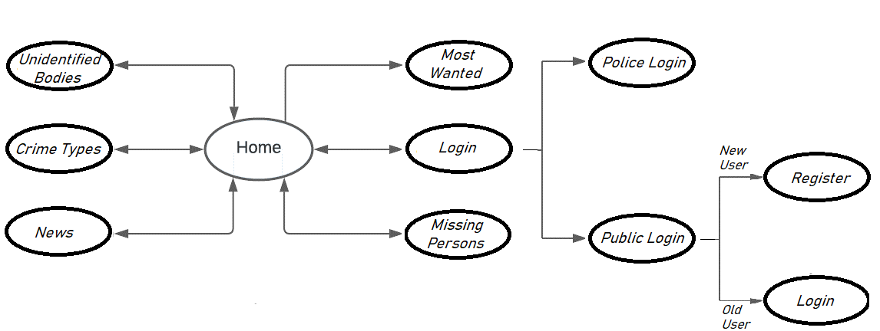

# System Design

## Proposed design

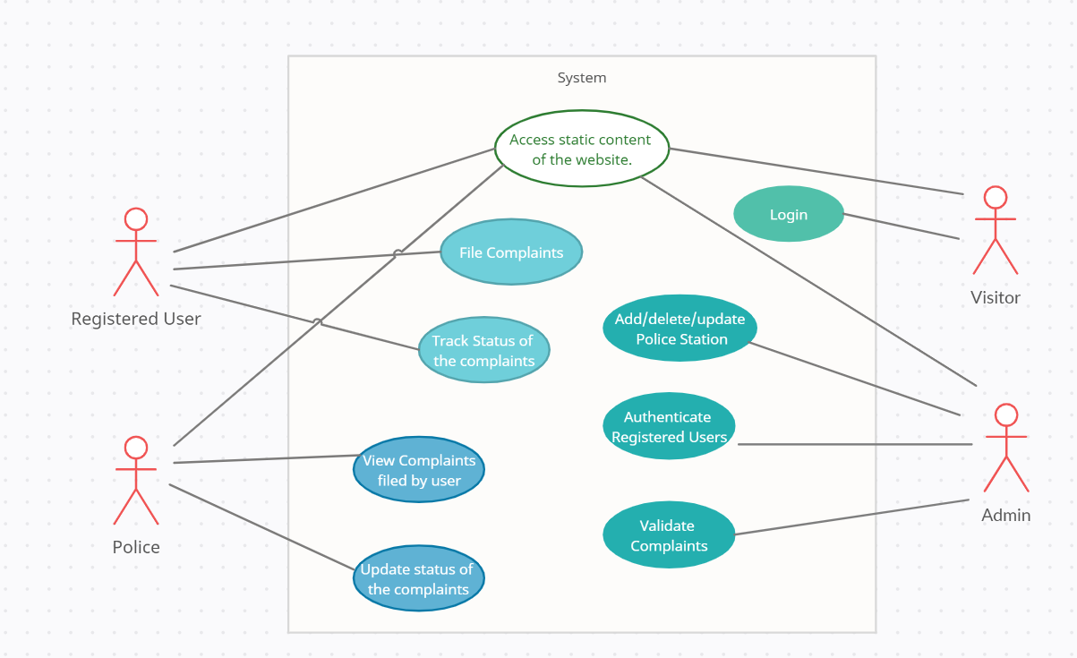

## Component inventory

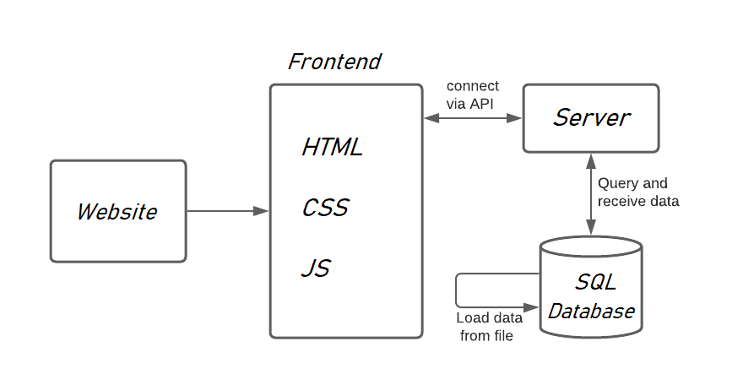

# Database Design

## Data Model

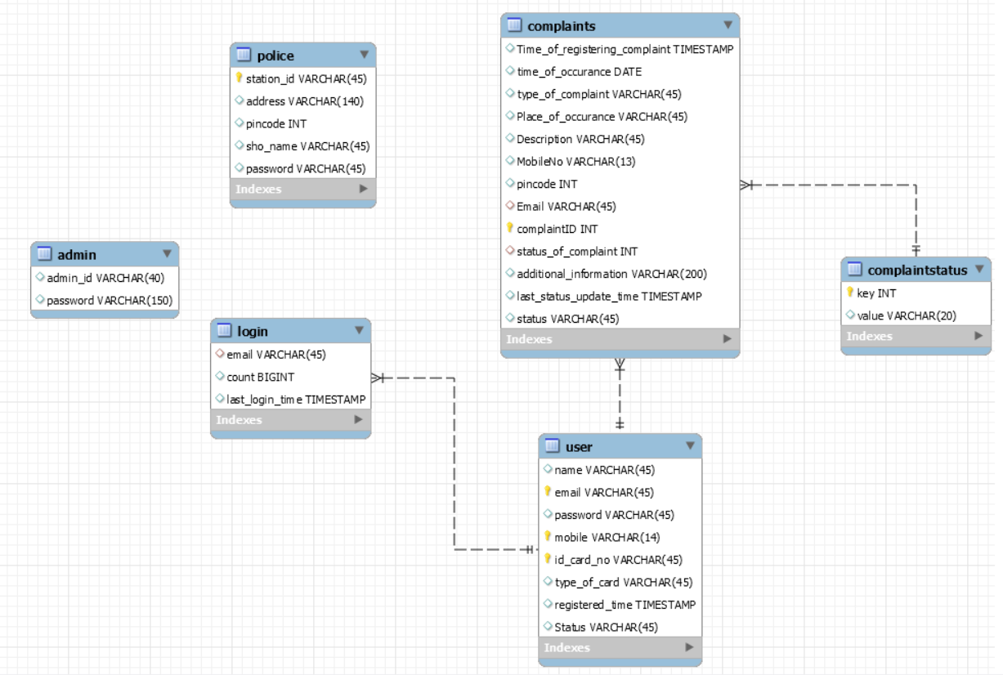

## Tables Structure

User Table:

|  |  |  |  |
| --- | --- | --- | --- |
| **Column Name** | **Data Type** | **Length** | **Nulls** |
| name  Email  Type_of_card  Password  Mobile  Id_card_no  Registered_time | Varchar  Varchar  varchar  Varchar  Int  Varchar  TIMESTAMP | 45  45  45  45  11  12 | Not Null  Not Null  Not Null  Not Null  Not Null  Not Null  Not Null |

               Complaint Table:

|  |  |  |  |
| --- | --- | --- | --- |
| **Column Name** | **Data Type** | **Length** | **Nulls** |
| Time_of_registering  Time_of_occurance  Type_of_complaint  Place_of_occurance  Description  MobileNo  PinCode  Email  complaintID  Status_of_complaint  Additional_information  Last_status_updatetime  Status | Timestamp  Date  Varchar  Varchar  Varchar  Int  Int  Varchar  Int  Varchar  Varchar  Timestamp  Varchar | 45  45  45  10  6  45  10  45  150    45 | Not Null  Not Null  Not Null  Not Null  Not Null  Not Null  Not Null  Not Null  Not Null  Not Null  Null  Not Null  Not Null |

Login Table:

|  |  |  |  |
| --- | --- | --- | --- |
| **Column Name** | **Data Type** | **Length** | **Nulls** |
| email  count  Last_login_time | Varchar  BigInt  Timestamp | 45 | Not Null  Not Null  Not Null |

Police Table:

|  |  |  |  |
| --- | --- | --- | --- |
| **Column Name** | **Data Type** | **Length** | **Nulls** |
| Station_id  Address  Pincode  Sho_name  password | Varchar  Varchar  INT  Varchar  Varchar | 45  140  6  45  45 | Not Null  Not Null  Not Null  Not Null  Not Null |

Complaint Status:

|  |  |  |  |
| --- | --- | --- | --- |
| **Column Name** | **Data Type** | **Length** | **Nulls** |
| Key  Value | Int  Varchar | 4  45 | Not Null  Not Null |

Admin:

|  |  |  |  |
| --- | --- | --- | --- |
| **Column Name** | **Data Type** | **Length** | **Nulls** |
| admin_id  password | Varchar  Varchar | 45  45 | Not Null  Not Null |

# Appendices

## Glossary

|  |  |
| --- | --- |
| **Acronyms** | **Definitions** |
|  |  |

## Other

# Terms & Conditions

***Disclaimer: Please do not circulate or distribute this document outside of Cognizant Network, We have a Zero Tolerance Policy. Kindly adhere to 100% Compliance at all times.***

# Change Log

*Please note that this table needs to be maintained even if a Configuration Management tool is used.*

|  |  |  |  |  |
| --- | --- | --- | --- | --- |
| Version Number | Changes made | | | |
| V<n.n> | *<If the change details are not explicitly documented in the table below, reference should be provided here>* | | | |
| Page no | Changed by | Effective date | Changes effected |
|  |  |  |  |
|  |  |  |  |
|  |  |  |  |
|  |  |  |  |